Segregation of Races Within a Community

Zach Stept

George Mason University

# Abstract

Segregation has always existed within communities, whether it is by race, religion, socio-economic status, and so much more. The most prevalent form of segregation is racial segregation. Over the years data has been collected in surveys such as the U.S. Census which has made it capable to map trends in how different racial groups move within communities. The major issue that comes with segregation is that people will keep on moving to different communities until they are happy with their neighbors. This is due to the social climate that exists within the U.S. as new issues arise such as wrongful deaths. There might not be a way to prevent people from moving as the social climate changes, but it is possible to learn the patterns of people moving and understand how this might affect the community.

*Keywords:* segregation, communities, race(s), happiness, social climate, neighborhoods, Washington, D.C.

# Introduction

The notion of segregation has been seen throughout history and there is a lack of knowledge about the effects of segregation on communities as well as how segregation can further impact future residential housing in terms of how satisfied the residents are within the community. This research will be conducted using the segregation model provided by NetLogo.

Segregation is a complex social phenomenon that is affected by multiple different variables such as race, socio-economic classes, individual preference, and much more. The goal of our research is to understand how segregation is formed and what can impact the outcome of different segregation scenarios where population density and other key variables listed above are present. This segregation model not only will analyze where people relocate within a community, but whether they are content with where they are living and who their neighbors are. By utilizing the NetLogo model, we can further make the model more complex and test different hypotheses on segregation.

The NetLogo segregation model output will illustrate the extent of how segregated the community is and what different variables can change the outcome. During our research, we can change the density and how similar we want the community to be in order to further analyze whether or not people become more segregated within their community, and if it is possible for more people to become happy while being in a segregated community. While analyzing the results, we can determine what the effects of the distance required to move has on segregation and the level of satisfaction amongst the neighbors. In order to better understand segregation, utilizing real-life examples is also another strategy that will be put forth to see how these individual preferences ripple throughout neighborhoods. Important questions to be answered in this research is what distribution of race, and other variables may be compatible with dynamically stable mixtures? What effect will the initial conditions have on the level of segregation?

# Background

Previous research has been conducted to look into racial segregation. The United States does a survey every ten years called the U.S. Census which has the intended use for making sure each community receives the funding that they need. However, it has been a major help in mapping racial segregation because it asks the question of “What is the race of Person 1/Person 2?” This is one type of survey that has allowed researchers to map the segregation within communities in order to understand the make-up of the community. However, the U.S. Census has a long list of races compared to the five types of races that are being used for the research conducted in this paper.

Mapping out racial segregation has also made it easier to see the level of diversity within a community. But it might be noticed that mapping racial segregation is almost the equivelant of mapping diversity because the amount of different races within an area leads to the amount of diversity. There has been a lot of research on segregation within major metropolitan cities. For instance, Michael McLaughlin from the Center for Data Innovation was able to map segregation and concluded, “an interactive map shows that people in cities such as Washington, D.C. mostly live in segregated neighborhoods even though they work in relatively diverse downtowns during the day. The visualizations also demonstrate that neighborhood segregation is increasing”. Although there are multiple ways to map segregation within communities, it is very effective in describing a situation that has been prominent within the United States.

The effects of segregated communities have impacted all who live within that community. For instance, communities that are more populated have worse schooling for the kids in that community. It has also been apparent that non-White communities tend to have more police convictions whether they are just or not. According to the University of Michigan Law School, “black people seven times more likely to be wrongfully convicted of murder than white people” and the statistics provided just get worse when it comes to sexual assualt and drug cases. The only reason this occurs is because throughout the existence of the U.S., African-America people have always been treated unfairly.

The biggest case of housing segregation that has resulted in issues like the one above is the New York City Housing Authority with the partnership of Robert Moses. The creation of the six-lane Cross Bronx Expressway took existing neighborhoods and destroyed them. It forced rich people to move and left the poor to stay and struggle. The poor who were historically African-American were in a way segregated by the government. Not only did the Cross Bronx Expressway destroy communities, but housing developments that were put up by New York City provided low-income housing for immigrants and African-American people. Over time these housing developments have influenced kids to participate in gangs and drug use.

Historically segregation was the separation of African-Americans and Whites and to this day it still maintains to be that way with the addition of a few more racial groups. Mapping segregation has been proven very useful in determining this. As the paper continues, it will become apparent how communities are still separated by race and how this has an effect on the community.

# Methodology

In order to better understand the segregation of races within a community, this paper will use a NetLogo model titled “Segregation” which is designed by Uri Wilensky of Northwestern University. The goal of this model is to see how the agents react with each other. Some might want to move closer to their kind (patch color) and others might just be happy where they are. After running this simulation, the model determines how segregated the community is and shows a plot of where each patch stands within that community. This model also contains various different features in order to simulate the ripple through the neighborhood which leads to large-scale patterns that help to determine the likelihood of segregation and the possible effects that it might contribute to the community.

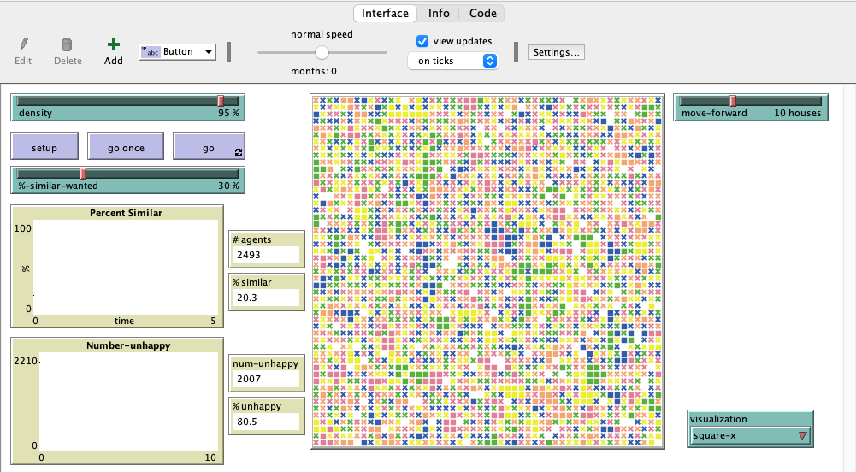

Figure 1

The above figure which is referred to as Figure 1 is an image of the initial setup of this model in the NetLogo program. This version of the model differs from the original NetLogo version in three different ways. The first is the addition of three more patch colors in order to represent the five most common race classification which include White, African-American, Asian, Hispanic, and others. The second difference is the addition of a slider that allows the simulator to control how far a patch is able to look for a new spot and once a new spot is found, they can then move. The third change is the identification of what each tick represents which has been changed to represent a month. However, each tick might not necessarily move at the same time within that month, e.g., one tick might move at the beginning of the month while another moves at the end of the month.

The other features within the model allow you to control the simulation as well by changing the input setting in an effort to make an effect on the output of the simulation. The first slider on the top-right labeled “density” allows the simulator to control how much of the neighborhood will be occupied by patches. In the real world there are always vacant homes and properties, so in order to resemble this the slider will stay within the 90 to 95% range. The slider below labeled “%-similar-wanted” controls how much each patch wishes to be surrounded by its own kind (patch color). For the research conducted, the slider will stay within the 25 to 50% range. This model also has the option to change the visualization of the patch, but that is not important for the research conducted. Though one should note that when using “square-x”, the square patches represent happy agents while the x represents unhappy agents who want to move somewhere else. The most important aspect of this model is the “% similar” monitor which tells the simulator how segregated the community ended up becoming.

The research for this paper will be conducted in two different ways. The first being the data collected from the NetLogo model after running numerous simulations and the second being real life examples. The NetLogo model will allow for a precise testing of the question in order to determine if the distance one can move affects the segregation of that community as well as the effect of how much alike one person wants to be with those around them. The goal of the real life examples is not only to hopefully keep the reader more interested, but to get a bigger picture of how this problem is occurring today and even how it has occurred in the past.

# Results

When conducting the research using the aforementioned NetLogo model, the use of BehaviorSpace became crucial in collecting data in a fast and easy way. The data collected came from 20 different runs (simulations). Three experiments were conducted and the data was collected onto a spreadsheet that also calculated the average number of turtles, the average number of ticks (months), the average density, and the standard deviation of the densities. The three experiments involved changing the move-forward slider from a distance of five, ten and fifteen. The following figure which is referred to as Figure 2 will show what the final output looks like when a simulation is completed. It is apparent that over a period of 45 months, all 2,469 agents were able to become happy. It is also apparent that this community is pretty segregated, but only 72.3% segregated. A comparison to segregation could be neighborhoods in New York City, i.e., Little Italy and Chinatown. However, each kind of agent is not isolated to its own kind, making a more diverse community.

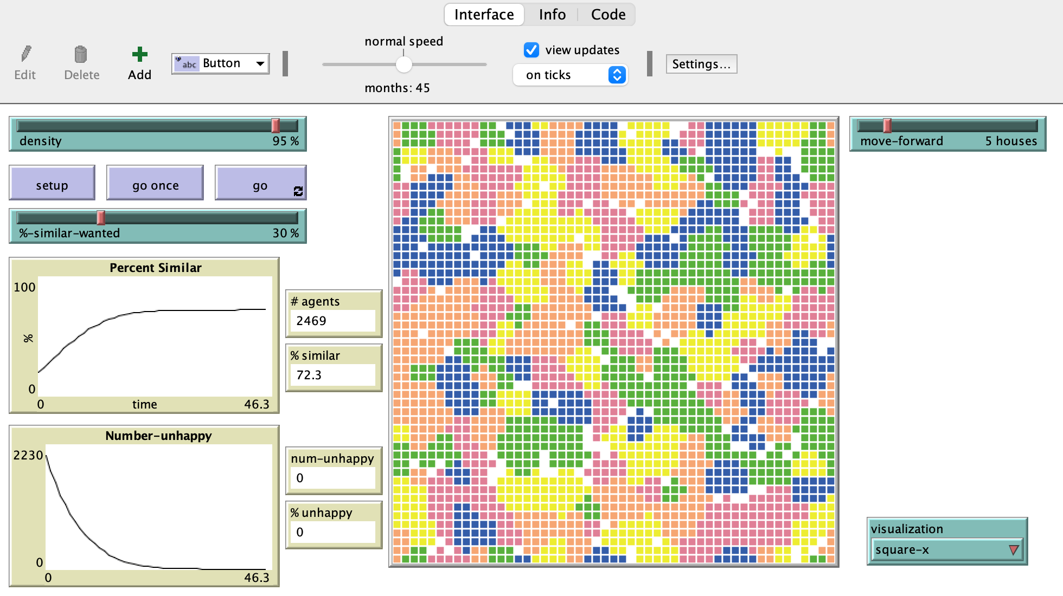

Figure 1

The three tables below are used to condense the data and will help to come to a conclusion of the main question of this paper. In table 1, each turtle was able to move five patches at a time, but only if they were unhappy with their neighbors. Throughout the 20 runs, there were on average 2,468 agents after rounding down, since you cannot have a partial person. The table 2 simulation allowed each turtle to move 10 patches at a time and with 20 runs, there were on average 2,473 agents. Table 3 has roughly a similar amount of agents with an average of 2,475 agents that were able to move 15 patches at a time. Just from these numbers, we are able to conclude that the experiments are roughly even and should produce similar numbers when it comes to segregation.

|  |  |  |  |  |  |  |  |  |  |  |  |  |  |  |  |  |  |  |  |  |  |  |  |  |  |  |  |  |  |  |  |  |
| --- | --- | --- | --- | --- | --- | --- | --- | --- | --- | --- | --- | --- | --- | --- | --- | --- | --- | --- | --- | --- | --- | --- | --- | --- | --- | --- | --- | --- | --- | --- | --- | --- |
| Table 1   |  |  | | --- | --- | | move-forward | 5 | | AVG turtles | 2468.85 | | AVG ticks (months) | 55.35 | | AVG percent-similar | 72.14 | | SD percent-similar | 0.75 | | Table 2   |  |  | | --- | --- | | move-forward | 10 | | AVG turtles | 2473.95 | | AVG ticks (months) | 48.1 | | AVG percent-similar | 72.89 | | SD percent-similar | 0.73 | | Table 3   |  |  | | --- | --- | | move-forward | 15 | | AVG turtles | 2475.4 | | AVG ticks (months) | 42 | | AVG percent-similar | 72.57 | | SD percent-similar | 0.65 | |

Each time the simulation is completed, the average density remains fairly similar which makes sense because each agent wants the community to be roughly 30% of their kind (patch color), meaning that the community can only be about 70% segregated. The major difference is the amount of months that it takes for the community to settle and everyone becomes happy. There is an apparent trend that shows a decrease in time (months) as agents are allotted more patches to move to. So, as the distance one can move increases, the faster everyone around them can become happy. This makes sense because it allows people to keep on looking at different houses in different neighborhoods until they find one that makes them happy. This also goes for those around them, so that they are accepting of those moving next to them.

When the number of patches allotted for an agent to move changes to any number other than the ones previously used, the trend maintains and the number of months for the community to settle will decrease, but will never reach lower than 30 months. However, the opposite happens when the agent can only move to the patch next to them, there is no limit to how long it will take for the community to settle, though it will at least take 100 months because the agents have a greater amount of people to consider as perfect neighbors. The most important thing to note is that changing the percentage of similarity within the community has the greatest impact. The lower the percentage, the less segregated the community is. Where on the other hand the higher the percentage, the longer it will take for the community to settle or in most cases it might never settle. However, it is very uncommon to find a community where people want to only live with their own race/ethnicity. This only exists in Chinatown and Little Italy because of immigration patterns. A great example of a city to observe happens to be the capital of the United States which has the most diverse population in the nation.

The Washington Post has an article entitled “America is more diverse than ever – but still segregated” by Aaron Williams and Armand Emomdjomeh. This article contains maps of both diversity and race in major metropolitan areas. It also includes a map that allows the reader to pick a location as well as a year, it then generates the diversity or race in that area and produces a short overview with statistics for the location chosen. Look at Washington, D.C. for example. As of 2016, White Americans account for 47 percent of the population making it the largest racial group in the city. This means non-White racial groups acccount for the other 53 percent which is up from 36 percent in 1990. The following figures known as Figure 3 and Figure 4 contain the map of the Washington, D.C. and the race and diversity of the area.

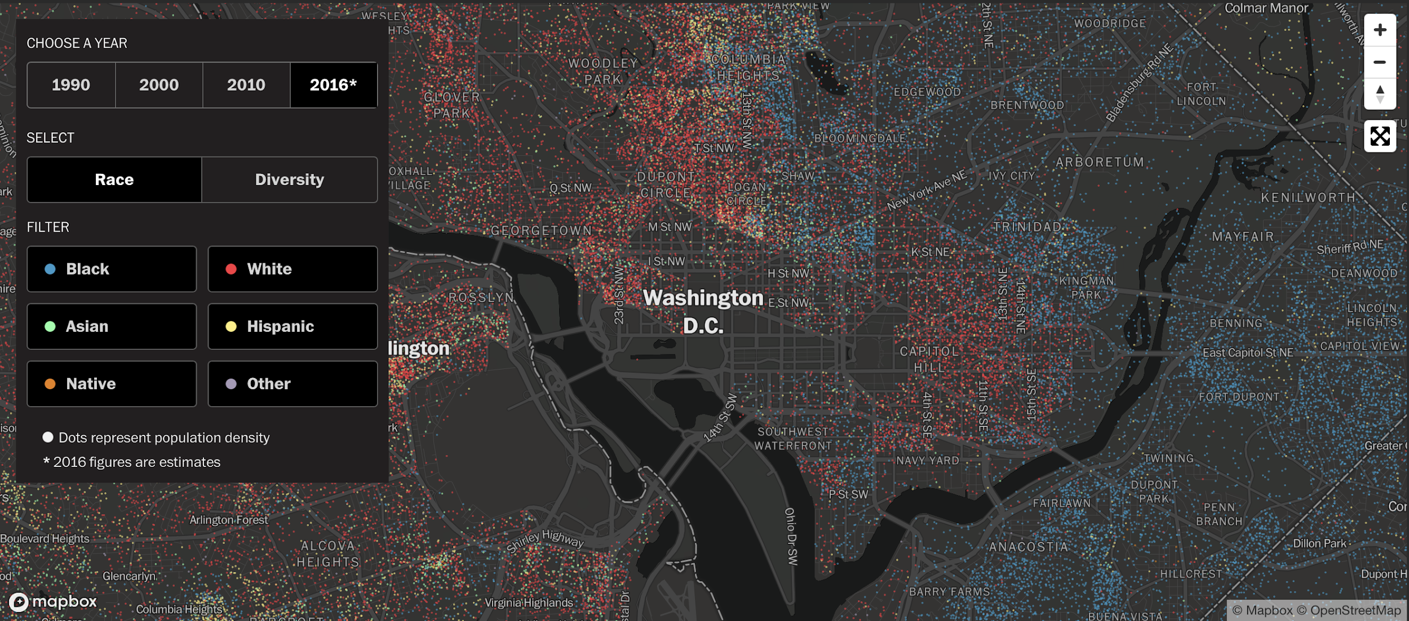

Figure 3

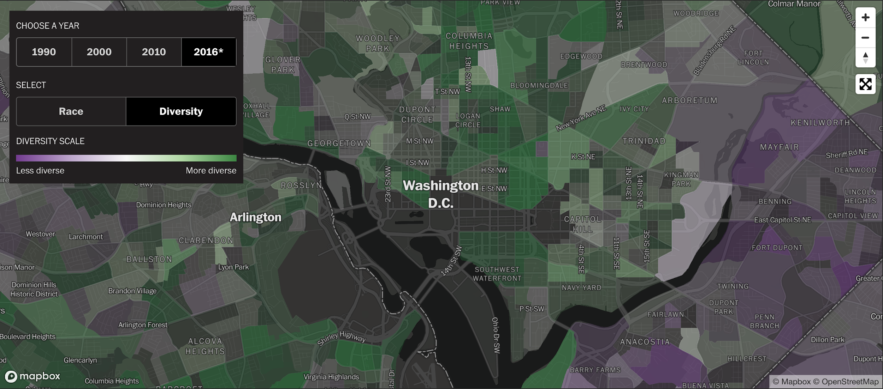

Figure 4

From Figure 3, it is extremely apparent that a majority of Washington, D.C. population is made up of White-Americans. Figure 4 captures the fact that there is a lot of diversity in Washington, D.C., but in some of the suburbs where it is majority African-American, there is an extreme lack of diversity. However, diversity is expected in a major metropolitan area and should always be changing. Looking further into the map on the Washington Post’s website it is apparent that diversity will change, especially as communities become even more developed and as new social issues arise.

# Discussion

Throughout multiple trials and experiments conducted, and data collected, multiple trends and patterns were found that explain different aspects of segregation and its correlation with happiness amongst individuals. Through 20 different simulation runs and three experiments with roughly the same number of agents we found that roughly 70 percent segregation rate in each simulation. The 70 percent segregation rate was consistent throughout the simulations which was surprising. We concluded that communities are generally 70 percent segregated meaning roughly 30 percent are of the same kind. We believe this happens due to many different factors such as the distance one can move, time period, and individual preferences.

The research simulations were effective in finding patterns involving segregation amongst communities as well as finding multiple patterns on what affects segregation. During the research, the goal was to analyze what causes segregation and can communities be happy within a certain level of segregation? The results show that communities can be happy within a community where 70 percent is segregated. The major difference in the simulations was the number of months that it took for the community to settle and for everyone to become happy. This trend was apparent in showing a decrease in months taken for agents to move to different patches/locations. The most important aspect of our analysis consisted of one huge factor which was the percentage of similarity within the community. The percentage of similarity within the community had the biggest impact and the lower the percentage, the less segregated the community became; while on the other hand the higher the percentage of segregation the longer it took for the community to settle which in some cases it never did.

Throughout the research there were multiple drawbacks that came from the simulation research on segregation. The major drawback to the research was that the model did not follow real life patterns. The model does not account for retail space and other socio-economic factors. Communities like Chinatown and Little Italy are both excellent examples of how immigration can lead to neighborhoods where segregation is prominent. The duration of the segregation of these cities is a testimony to how these types of communities are content and per individual sake “happy” when it comes to a certain level of segregation. Also, the model does not account for different social politics, retail space, economic issues and so on.

# Summary/Conclusion

While the research conducted and used to analyze the effects of segregation within a community does not lead to ways of solving this issue, it does help understand the patterns that are involved. History has taught us that segregation has led to unfair and unjust social lifes for different racial groups. The most prominent unfair and unjust racial group is African-Americans. As mentioned earlier they are more likely to be wrongfully convicted. However, it has been discovered that this is an issue that involves multiple factors such as location of housing, past history of the U.S., and how people perceive something.

Most people are unsatisfied with whom they live near and decide to move until they find a house that is in a desired location. This led to the discussion of when would the moving stop in order to create that perfect community. The NetLogo simulation helped us realize that it could take years for people to be satisfied with their neighborhood. However, that perfect community was discovered to be built faster if people expanded their horizons and looked for a new house farther away from where they were living. It was also discovered that the more people aimed to be segregated, the harder it was to achieve that goal.

The main issues discovered with this research was that it was unable to account for retail space and only examined a society that had no current social issues. Though issues were discovered that made this research imperfect, the findings are still applicable because they are universal. The NetLogo model has made it easier to understand how segregation has shaped a community. This information is then able to be applied to real-life situations in order to better understand how these situations might play out. Since the research used in this paper involved segregation mapping from Washington, D.C., it has been possible to come to the conclusion that more African-Americans choose to move to the suburbs because they feel that the city is unsafe for their families due to police shootings and other issues. Segregation mapping has made it much easier to see how a population of people have been moving around over a period of years, while the NetLogo model has made it possible to understand how segregation might shape a community in a perfect scenario with no issues.

References

McLaughlin, M. (2019, February 23). *Mapping Segregation in America At Home and Work*. Center for Data Innovation. https://datainnovation.org/2019/02/mapping-segregation-in-america-at-home-and-work/.

*Race and Wrongful Convictions*. https://www.law.umich.edu/special/exoneration/Documents/RaceReport2.7.pdf.

Wilensky, U. (1997). NetLogo Segregation model. [http://ccl.northwestern.edu/netlogo/models/Segregation.](http://ccl.northwestern.edu/netlogo/models/Segregation) Center for Connected Learning and Computer-Based Modeling, Northwestern University, Evanston, IL.

Wilensky, U. (1999). NetLogo. [http://ccl.northwestern.edu/netlogo/.](http://ccl.northwestern.edu/netlogo/) Center for Connected Learning and Computer-Based Modeling, Northwestern University, Evanston, IL.

Williams, A., & Emamdjomeh, A. (2018, May 10). Analysis | America is more diverse than ever - but still segregated. Retrieved November 25, 2020, from <https://www.washingtonpost.com/graphics/2018/national/segregation-us-cities/>